
Department of Computer Science
Term Project Proposal, Fall 2023-24

Course | CSC 2108 - Introduction To Database [Section: F ] | Group | 1

Group Members:
Student ID | Name | Contribution
22-48505-3 | MD. Wahiduzzaman Khan Dip | 30%
22-48930-3 | MD. Khalid Hasan | 30%
22-48345-3 | MD. AL Faysal | 20%
22-49753-3 | Estiak Rahman Ayon | 20%

Project Title:
Tourism Management System

Project Description:
INTRODUCTION:
Organizing travel plans has grown more difficult in the fast-paced world of today. Our project is based on a tourism management system that aims to establish a comprehensive and efficient solution for managing travel arrangements. This project aims to simplify the process of storing and retrieving important travel-related data, including reservations for flights, hotel booking, meals, and other accommodations, by building a centralized database. By successfully implementing this project, the travel industry can benefit from improved efficiency and seamless travel experience for both travel agencies and individual users.

CASE STUDY:
In a tourism management system, a travel agency employs several employees to handle various tasks. Various types of employees work for a travel agency. A travel agency usually contains an agency ID, name, address, phone number, and email address. On the other hand, an employee has an employee ID, name, date of birth, job type, salary, and different skills. Customers can approach a travel agency. A travel agency services many customers. A customer registers with a customer ID, name, address, phone number, email, and membership level. All kinds of addresses are composed of city, country, and zip code. A customer makes payments for various facilities. A payment process may include Pay ID, amount, date, etc. A customer takes flights for traveling. A flight includes flight number, airline, departure and arrival which is composed by country and time. A customer uses various types of local transportation. Local transportation generally has a transport number, booking date, pick-up location, drop-in location, and mode of transport. Customers make reservations at hotels. On the other hand, A hotel offers accommodations to the customers and the customer gets accommodations. To make accommodations, there is an accommodation ID, in date, out date, room type and room number. A hotel manages food booking. Different types of food bookings are offered by a hotel. Food booking is maintained by booking ID, booking date, meal type, and total number of guests. In total, there are 9 entities in the project.

ER DIAGRAM:

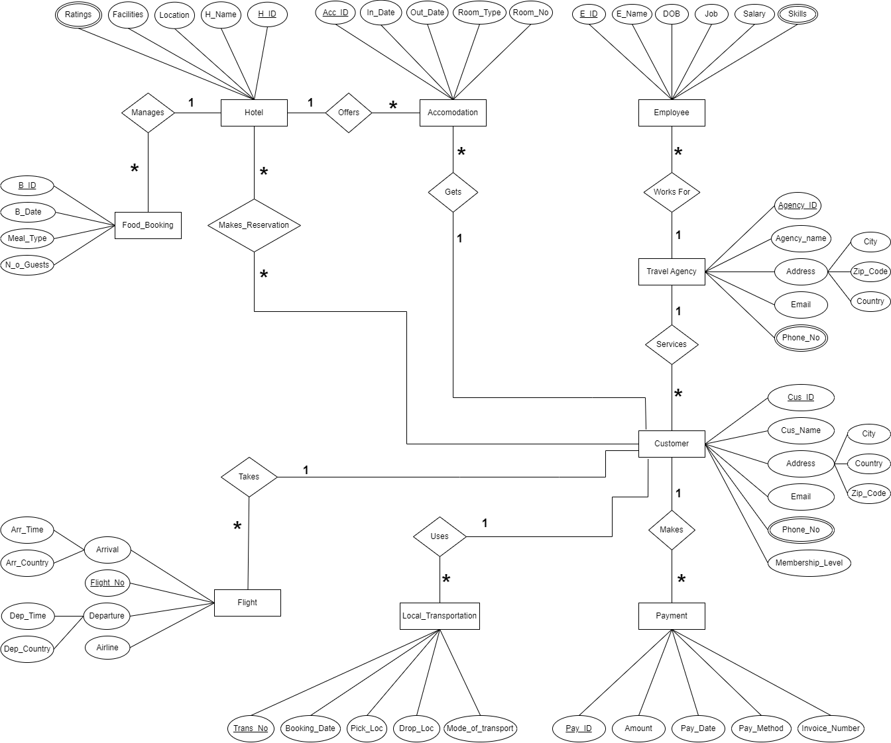

Fig-1: ER-Diagram for Tourism Management System

